**DEPARTMENT OF COMPUTER SCIENCE- UBIT**

**LIBRARY MANAGEMENT SYSTEM**

**ADVANCED SOFTWARE ENGINEERING**

**CSSE-414**

CLASS: BSSE (4th SEMESTER)

TEACHER: SIR UMAIR KHAN

**GROUP MEMBERS:**

**MOHSIN ALI (B16158045)**

**MUHAMMAD AMIR (B16158047)**

**MUHAMMAD TANEER KHAN (B16158061)**

**JUNAID ALI (B16158039)**

**ASAD UR RAHMAN (B16158015)**

* **What did the others, techniques and methodologies used, evaluation methods, results?**

**METHODOLOGIES & TECHNIQUES:**

For Library Management System we used Agile Development methodology and other techniques.

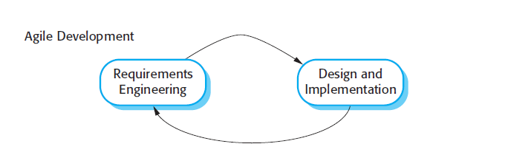

**EVALUATION METHODS:**

**Mixed Methods is used for evaluation of library management system, tutorial based approach and other sources.**

**RESULTS:**

**Library Management gives Add Books, Delete Books, Books Data, Issue Books, Student Registration, and Student Data.**

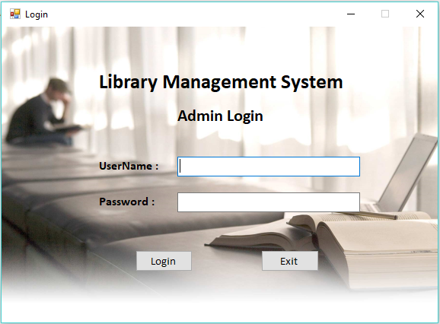

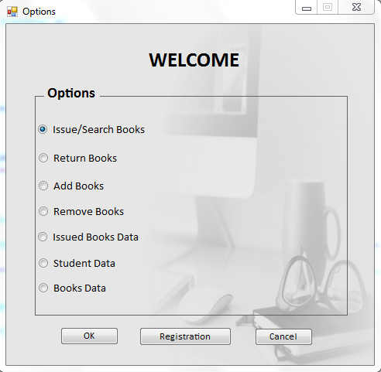

* **Important names in field, research teams?**

Library Management System Project the major field is Database in which all data of books and students can be stored and can be manipulated it.

Library Management System Project Database can be kept information about books to be issued and retained in shelf.

In LMS registration to be modify by person who handle all data.

* **Related articles and books?**

**BOOKS:**

* [Lean Library Management: Eleven Strategies for Reducing Costs and Improving Services](https://www.goodreads.com/book/show/10199631-lean-library-management).
* Library Management, Volume 1.
* **Resources and tools available?**
* **Libero** https://libero.com.au/

**Introduction:**

LIBERO is the perfect solution to your eResource, learning, and discovery requirements. Customisation options, ongoing product development and LIBERO WebServices ensure the library continues to effectively support the curriculum and the long-term strategy of your institution.

* **ABCD** <http://abcd.netcat.be/files/>

**Introduction:**   
ABCD is web-based integrated library management software comprising the main basic library functions. The main characteristics of ABCD are the coverage of the main library functions, its web centrality and its development and maintenance under the methodology of Free and Open Source Software.

* **LibreSource** [http://dev.libresource.org](http://dev.libresource.org/)

**Introduction:**   
LibreSource is a versatile collaborative platform. Open Source, modular and highly customizable, LibreSource is adapted to the collaborative software development (forge), groupware, community leading, e-archiving and Web publishing.